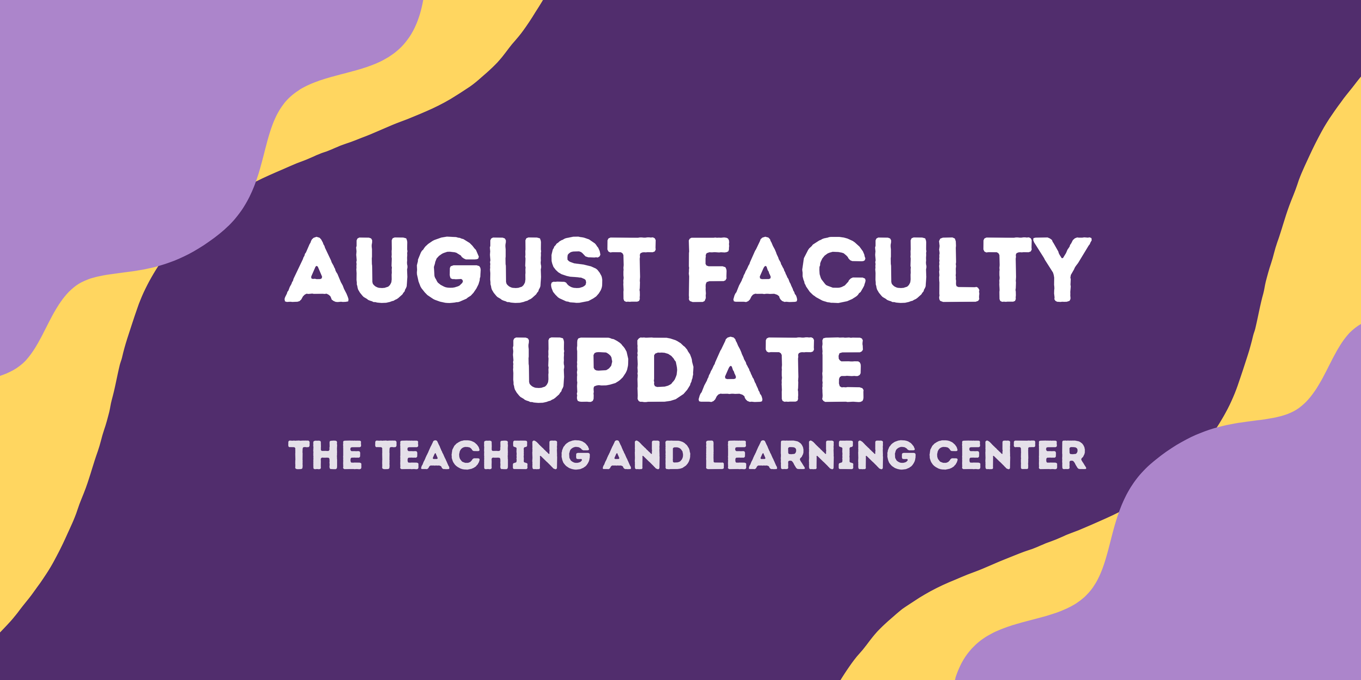

Welcome back!
We hope that you had a good summer and are returning renewed. The Teaching and Learning Center is here to support you as you prepare to teach this fall.

We are also excited to announce that the TLC website is now live! The site is a work in progress and we will be adding more content and refining it over the semester. We appreciate your patience and understanding as we continue to work on it.

Below, you'll find a variety of teaching resources, initiatives, events, and updates. Feel free to use the links in the Table of Contents to skip directly to any item that catches your attention.

New Teaching Resources

Teaching with Generative AI Toolkit
Wondering if and how to engage with generative AI tools (like ChatGPT), in your courses? We have created an AI resource toolkit that provides you with some guidance for developing an approach to using AI tools that suits your teaching context. The toolkit offers strategies for effectively communicating with students about generative AI, as well as a variety of strategies for incorporating AI tools into your courses. We encourage you to reach out to your instructional designer to discuss options for your specific teaching context.

New Online Faculty Development Program Now Open
As of Monday, August 8, the new Online Faculty Development Program (OFD) has arrived in an always available format, transitioning away from scheduled offerings. Faculty interested in completing OFD can now self-enroll into the program’s D2L site using the Discover feature and start working when it fits their schedule.
More details are available in the New OFD Announcement. If you have any questions about these changes, please contact the Teaching and Learning Center.

Open Initiatives

Call for Applications: Gen Ed ePortfolio Faculty Learning Community
We are excited to announce an opportunity to join a Faculty Learning Community (FLC) centered on the Gen Ed Google Sites ePortfolio! The FLC will meet during Fall 2023. Estimated total time commitment across the semester is 9 hours. Compensation is $500 dual-comp.

Applications are due by August 25, 2023 by 5PM. See the Call for Applications for further details and how to apply.

Questions about this FLC or the application process should be directed to Janneken Smucker, Gen Ed Council ePortfolio Director (jsmucker@wcupa.edu).

Call for Applications: Diversity & Inclusion Faculty Learning Community
Are you passionate about teaching but wonder who you might be leaving behind in class? Do you need help getting started with inclusive teaching? The Diversity and Inclusion Faculty Learning Community (DIFLC) might be for you! Together, we will build better skills in promoting equity and diversity in the classroom, discuss challenges we face when creating inclusive learning environments, and construct guidelines for equitable teaching.

The FLC will meet six times throughout the 2023-24 academic year via Zoom on Thursday evenings. All faculty are eligible to participate. Participating faculty will receive a stipend of $500 for the year, as well as several topical books.

If you’re interested in the DIFLC, apply by completing the brief DIFLC Survey by September 1, 2023. For more information, please review the DIFLC Call for Applications.

If you have any questions, please contact the DIFLC co-facilitators, Dr. Kimberly E. Johnson (kjohnson4@wcupa.edu) and Dr. Zeinab Baba (zbaba@wcupa.edu).

Call for Proposals: Quality Matters Initiative
With the rapid growth of online education at West Chester University, the Teaching and Learning Center looked to ensure that our online courses are built upon research-backed standards. Therefore, we partnered with Quality Matters (QM), a non-profit organization that specializes in standards for quality assurance for online course and program design. We run this initiative each academic year in which faculty members are compensated for preparing their courses for review and obtaining QM certification. More details about the opportunity are available on the Call for Proposals.

Applications are due by Friday, October 6, 2023.

Upcoming Events & Workshops

New! Teaching Strides
Join us this Fall for a new professional development opportunity that combines physical activity with meaningful conversation! Each Tuesday, meet at the Ram Statue in front of Old Library at 11:30 am to join us for a discussion on a teaching related topic or theme as we walk around campus. To learn more, visit our website.

Not interested in walking, but still want to talk about the week’s teaching topic? Join us on Wednesday at 11:30 on Zoom for 30 minutes of conversation around each week’s topic.
- 08/29 - Building Class Community
- 09/05 - Professional Learning Communities
- 09/12 - Student Engagement Strategies

Registration Open: CELT Book Club
Join the CELT Book Club this fall semester to read and discuss Relationship-Rich Education: How Human Connections Drive Student Success in College by Peter Felten and Leo M. Lambert (2020). Because the West Chester University Library has an unlimited e-book license for this title, CELT will offer our book club selection as an e-book rather than send hard copies. You may access the book here, when logged in to the library with your WCU credentials.

We will have two meetings during the semester:
- Wednesday, Oct. 4 at 3:00 PM or Thursday, Oct. 5 at 12:30 PM
- Wednesday, Nov. 8 at 3:00 PM or Thursday, Nov. 9 at 12:30 PM
Register now and download the book to start reading!

Registration Open: Teaching with AI Webinar Series
Build your AI literacy by attending a three-part webinar series on incorporating AI tools and strategies into your instructional practice. Hosted by TLC staff, these hour-long Zoom sessions start with a brief overview of generative AI, spend 30 minutes on the session’s topic, and end with time for questions and conversation. The first workshop will focus on Conversations with Studentsand will be held on Wednesday, September 13 at 10:00am. Register for 1, 2, or all 3 webinars!

Program Updates

PA-ADOPT: New eTextbook Releases
The PA-ADOPT program is proud to announce that two additional books have been released:
- Chemistry Techniques and Explorations: An Introductory Chemistry Laboratory Manual, by Dr. Daniel R. Albert, Associate Professor of Chemistry at Millersville University
- Introduction to Women’s & Gender Studies by Dr. Colleen Lutz Clemens, Professor of Non-Western Literatures and Director of Women's, Gender, and Sexuality Studies at Kutztown University
We hope West Chester faculty will consider using our books in your courses. If you are interested, please reach out to Marc Drumm (MDrumm@wcupa.edu). More free and open eTextbooks will be made available over the next couple of years – keep your eye on this newsletter for announcements of future releases!

Stay Connected

TLC Drop-in Hours
Getting your fall courses ready? Take advantage of the TLC Office Hours!Faculty can drop-in (no appointment required) to meet with one of our associate instructional designers for one-on-one support face-to-face or via Zoom. Our designers can assist with designing courses for any modality, creating and revising learning activities and assessments, selecting and incorporating instructional technology, and adhering to accessibility standards. We look forward to seeing you during the Office Hours listed below.
Virtual Office Hours: Zoom
Monday through Thursday, 1:30pm to 2:30pm

In-Person Office Hours: Anderson Hall, Room 103
Tuesday & Friday, 9:00am to 11:00am

Instructional Design Services
Schedule an appointment with your dedicated instructional designer for assistance with course design and pedagogy strategies for courses you are teaching in any modality. If you are not sure about who is your assigned designer, reach out to us at tlc@wcupa.edu for help.

ODLI on Air Podcast
A special surprise summer solstice episode, OLC Conference Recap arrived on June 21. If you're curious about the state of online learning broadly or how members of the TLC think about our work, check it out!
Season 3 starts on August 30.

