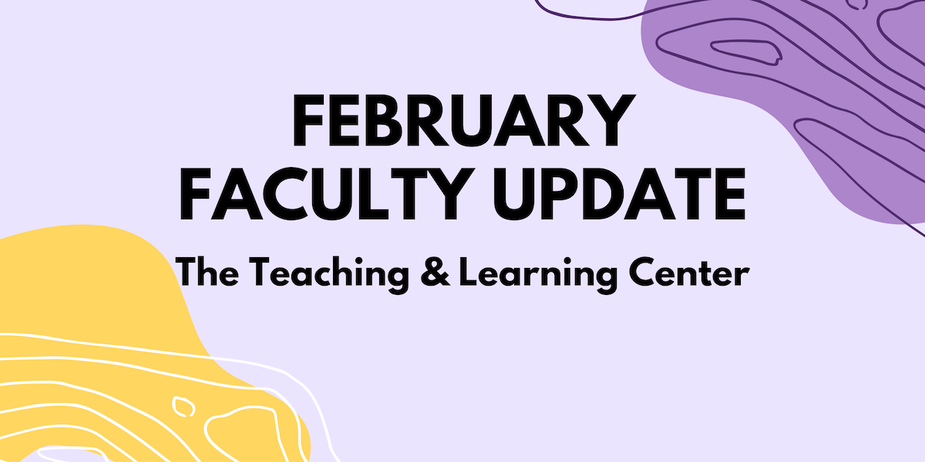

# Open Calls & Initiatives

## (Due Feb 7) Teaching Circle: Power, Privilege, and Inequality

The Teaching and Learning Center (TLC) invites you to join our Spring Teaching Circle focused on teaching about systems of power, inequality and privilege. The idea for this teaching circle was inspired by conversations with colleagues who wanted to connect with others who are teaching about power, privilege and structural inequalities in their courses.

Faculty at all experience levels who may currently or plan to teach courses on historically marginalized groups and structural inequalities or want to incorporate these topics into existing courses are welcome to participate. To learn more, [visit our website](https://www.wcupa.edu/tlc/flc.aspx), or to express interest in participating, complete the [online registration form](https://wcupa.co1.qualtrics.com/jfe/form/SV_1YpZyffkNk0qV2C) by **Friday, February 7**.

## (Due Feb 17) Join CELT’s Spring Book Club

This semester, the CELT Book Club will be reading [*Grading for Growth: A Guide to Alternative Grading Practices that Promote Authentic Learning and Student Engagement in Higher Education*](https://www.routledge.com/Grading-for-Growth-A-Guide-to-Alternative-Grading-Practices-that-Promote-Authentic-Learning-and-Student-Engagement-in-Higher-Education/Clark-Talbert/p/book/9781642673814) by David Clark and Robert Talbert (2023). This book targets faculty interested in exploring alternative forms of learning assessment as well as those currently using alternative grading systems who are looking for ideas and options to refine practice.

[Sign up now to reserve your spot!](https://wcupa.co1.qualtrics.com/jfe/form/SV_dgTLZU75mulGH2e) We will provide participants copies of the book if you can commit to attending two meetings on Zoom, one in February and one in April. For more information, [visit our website](https://www.wcupa.edu/tlc/book-clubs.aspx).

## (Due Mar 1) 2025-26 CELT Professional Development Award

The Committee for Excellence in Learning and Teaching offers an annual professional development award for up to $2,000 for pedagogical and curricular innovations leading to student success. These funds are to encourage the implementation of new and innovative projects that would not be possible without this financial support. Up to four projects will be selected for funds up to $2,000 per project.

Proposals are due **March 1**. For more information, [visit our blog](https://wcu-tlc.org/pd/celt-announces-2025-26-professional-development-award/) or [review the full guidelines](https://wcupa.sharepoint.com/:b:/s/AA/ded/ESAqPAmosp5LnL_7nKzK9r8Bhdj2DGHeeoYrboP8zLGNGg?e=TXoDJf); if you have any questions, please reach out to CELT Faculty Associate Janneken Smucker ([jsmucker@wcupa.edu](mailto:jsmucker@wcupa.edu)).

## (Due Mar 30) Celebration of Teaching: Call for Proposals

The TLC invites proposals for two of the Celebration of Teaching events.

1. Facilitate a 40-minute hands-on small group mini-workshop demonstrating a teaching technology or teaching technique.
2. Present a teaching concept, idea, strategy, or activity at the Teaching Excellence Showcase.

For more details on both opportunities and the proposal form, see the [Celebration of Teaching blog post](https://wcu-tlc.org/pd/2025-celebration-of-teaching/). Proposals are due by **Sunday, March 30**.

# Upcoming Events

## (Virtual: Feb 13) Motivating Assignments: Balancing Rigor, Compassion, and Engagement

When educators discuss assignments, the conversation often centers on their effectiveness in assessing student learning. In the age of generative AI, the focus has shifted toward creating 'AI-proof' assignments to minimize cheating. What if we reimagined assignments as a strategy for enhancing student engagement? What would that look like?

Join us on **Thursday, February 13** for a virtual interactive workshop led by CESW's Drs. Hodes and Mohajeri, who will share their approaches to creating assignments designed to increase student engagement and motivation. Moving beyond traditional assessment frameworks, this session will explore how assignments can serve as catalysts for enhancing student motivation, creativity, and authentic learning. [Register now](https://wcupa.co1.qualtrics.com/jfe/form/SV_9NqM23UKaipEbnE) to reserve your spot!

## (Virtual: Feb 20) Promotion Panel

Join the Faculty Mentoring Committee and the TLC to talk with a panel of professors who have recently been through the promotion process. All levels of promotion will be addressed. The panel discussion will be held on **Thursday, February 20** from 12:30 to 1:30pm. [RSVP and submit questions for the promotion panelists](https://wcupa.co1.qualtrics.com/jfe/form/SV_9uaE6skVzpQFKf4) today!

Questions? Contact Ralph Sorrentino ([rsorrentino@wcupa.edu](mailto:rsorrentino@wcupa.edu)) or Michelle Blake ([mblake@wcupa.edu](mailto:mblake@wcupa.edu)), Co-Chairs of the Faculty Mentoring Committee.

## (Virtual: Feb 28) Interactive Session: Allyship is Leadership

How might we lead more effectively? How do we move beyond awareness to effective allyship? We invite faculty and staff to discuss these topics and more in our virtual interactive session on **Friday, February 28**.

This session is presented in collaboration with the Multicultural Faculty Commission, Faculty Ombuds Office, and the Teaching and Learning Center. Facilitated by Janet Chang (chair of MFC) and Joan Woolfrey (Faculty Ombuds), this interactive session will discuss strategies & challenges for promoting effective allyship and provide opportunities to discuss [*Stories from the Front of the Room*](https://www.vitalsource.com/products/stories-from-the-front-of-the-room-michelle-harris-v9781475825183). If you would like to participate in this session, a complimentary copy of this book is available from the Teaching and Learning Center.

If you're interested, [register now](https://wcupa.co1.qualtrics.com/jfe/form/SV_1MS4icJu24gkThs), or visit [the TLC website](https://www.wcupa.edu/tlc/events.aspx) to learn more. If you have any questions, please contact [Janet Chang](mailto:jchang@wcupa.edu?subject=) or [Joan Woolfrey](mailto:jwoolfrey@wcupa.edu?subject=).

## (Virtual) AI in Action @ WCU

30-minute interactive webinars to inspire and motivate you to consider new ways to engage with AI in your teaching, scholarship, and service. Each session will feature a different WCU presenter. All sessions start with a 5 minute introduction, followed by a 15 minute presentation, and end with 10 minutes of questions and discussion. Each webinar will be recorded for later viewing.

Visit the [AI in Action blog post](https://wcu-tlc.org/pd/ai-in-action-wcu/) to register to attend an upcoming virtual session or view previous session recordings. If you're willing to share your own experiences working with generative AI, complete [our interest form](https://wcupa.co1.qualtrics.com/jfe/form/SV_1YVWtISHaJVHo22) or reach out to us at [tlc@wcupa.edu](mailto:tlc@wcupa.edu?subject=)!

## (In-person: May 8) Save the Date for the 2025 Celebration of Teaching!

Incredible teaching happens every day across WCU! Join us on **Thursday, May 8** for a series of four events to sample and discover new WCU teaching innovations, dialog with peers on teaching topics, and celebrate the teaching excellence that happens across WCU. The day's events will include mini-workshops, our 10th annual Teaching Excellence Showcase, a virtual keynote presentation from spring book club author [Robert Talbert](https://rtalbert.org/), and the TLC Teaching Awards Ceremony. [Learn more on the TLC blog!](https://wcu-tlc.org/pd/2025-celebration-of-teaching/)

# Program Updates

## Spring 2025 Technology Roundup

The Technology Roundup is a blog feature that is released each Fall and Spring semester to keep our community of educators informed on the latest available instructional technologies that are supported by the university. Check out the [Spring 2025 edition](https://wcu-tlc.org/instructional-technology/technology-roundup-spring-2025/)!

## Online Faculty Development Program

Need to earn or renew your CAPC distance education credential? Faculty can now self-enroll into the OFD program’s D2L site using the [Discover feature](https://wcupaprod.service-now.com/kb?id=kb_article_view&sysparm_article=KB0010869)! Start working whenever it fits your schedule.

# Stay Connected

## Connect with Us

The Teaching and Learning Center is far more than just a newsletter! Our website hosts a variety of [teaching resources](https://www.wcupa.edu/tlc/teaching-resources.aspx) and our full [Event Calendar](https://www.wcupa.edu/tlc/events.aspx). To get in touch, feel free to [send us an email](mailto:tlc@wcupa.edu?subject=), or stop by our [drop-in hours](https://www.wcupa.edu/tlc/drop-in.aspx) to speak live with one of our designers.