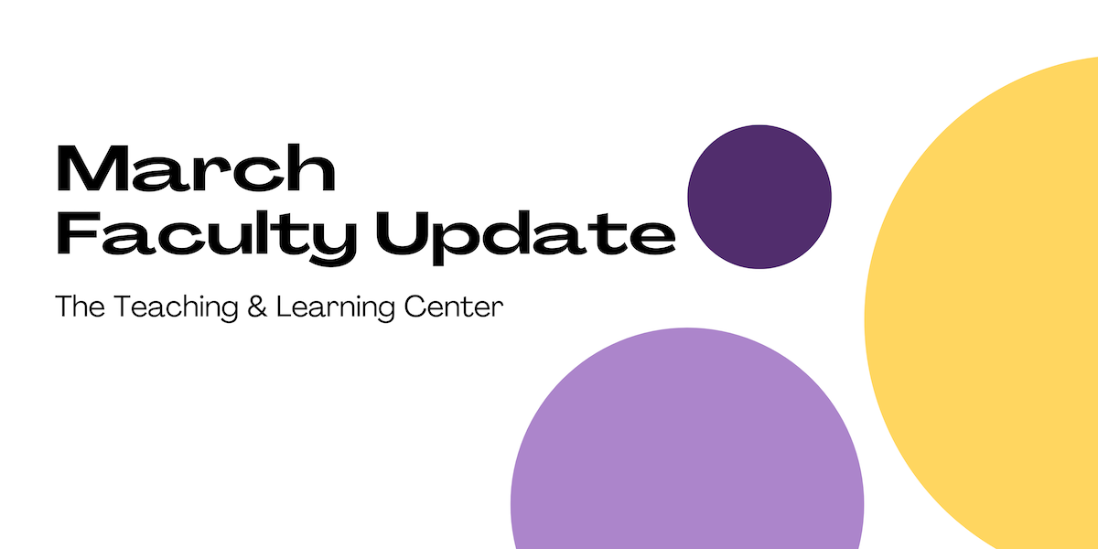

# Open Calls & Initiatives

## (Due Mar 28) WCU Faculty Success Fellowship

The Teaching and Learning Center, Office of Research and Sponsored Programs, and Office of Equal Opportunity and Compliance invite applications for our inaugural, joint-funded Faculty Success Fellowship (FSF). We will fund one fellow’s tuition to attend 2025’s [10-week National Center for Faculty Development and Diversity (NCFDD) Summer Faculty Success Program](https://www.ncfdd.org/sessions/fspsummer2025), an online professional development opportunity designed to empower faculty members with the skills and strategies needed to enhance their scholarly productivity, balance their workload, and achieve academic excellence.

You can find [more details, including full application materials,](https://wcu-tlc.org/pd/faculty-success-fellowship/) on our blog. Applications are due **Sunday, March 28**.

## (Due Mar 30) Celebration of Teaching: Call for Proposals

The TLC invites proposals for two of the Celebration of Teaching events.

1. Facilitate a 40-minute hands-on small group mini-workshop demonstrating a teaching technology or teaching technique.
2. Present a teaching concept, idea, strategy, or activity at the Teaching Excellence Showcase.

For more details on both opportunities and the proposal form, see the [Celebration of Teaching blog post](https://wcu-tlc.org/pd/2025-celebration-of-teaching/). Proposals are due by **Sunday, March 30**.

## (Due Mar 30) CCESI Faculty Award for Community Engaged Learning

Each year, the Center for Civic Engagement and Social Impact (CCESI) honors one of our many outstanding faculty for their use of community engaged learning pedagogy in their course offerings. Community engaged learning is a high impact teaching method that combines community service with curricular goals by focusing on critical, reflective thinking and civic responsibility.

The [online nomination form](https://docs.google.com/forms/d/e/1FAIpQLScmZd0uatflbp-rrVHtOP_jqcN2SiRow7gj5gfTNjcPSE3T-Q/viewform) is now open. Nominations by deans, department chairs, faculty colleagues, or self-nominations will be accepted through **Sunday, March 30**. The award recipient will receive a $500 faculty development award. Please direct any questions to [ccesi@wcupa.edu](mailto:ccesi@wcupa.edu).

## (Due Mar 31) 2025-26 CELT Professional Development Award

The Committee for Excellence in Learning and Teaching offers an annual professional development award for up to $2,000 for pedagogical and curricular innovations leading to student success. These funds are to encourage the implementation of new and innovative projects that would not be possible without this financial support. Up to four projects will be selected for funds up to $2,000 per project.

Proposals are due **March 31**. For more information, [visit our blog](https://wcu-tlc.org/pd/celt-announces-2025-26-professional-development-award/) or [review the full guidelines](https://wcupa.sharepoint.com/:b:/s/AA/ded/ESAqPAmosp5LnL_7nKzK9r8Bhdj2DGHeeoYrboP8zLGNGg?e=TXoDJf); if you have any questions, please reach out to CELT Faculty Associate Janneken Smucker ([jsmucker@wcupa.edu](mailto:jsmucker@wcupa.edu)).

## (Due Apr 16) Call for Proposals: Quality Matters Summer Camp

The TLC is consolidating our year-long Quality Matters (QM) course review into a three-week QM Summer Camp from June 2 to June 20, 2025. This streamlined format will promote cohort collaboration, consolidate course preparation, and allow you to focus on teaching during the academic year. At the end of the summer camp, your course will be ready for QM review. Faculty who earn certification are eligible for a stipend.

The deadline for applications is **Wednesday, April 16**. Read the [full call for proposals](https://wcupa.sharepoint.com/:w:/s/AA/ded/ERITppetIi1Ou9WjzeUUzYYBAyJb1k187B0jHAq4onyipg?e=S58CY3) for more information, or [submit an application](https://wcupa.co1.qualtrics.com/jfe/form/SV_6A4v7MYGyERH4km) today! If you have any questions, please contact the TLC.

## (Ongoing) Seeking Faculty Teaching Exemplars

The TLC is seeking faculty interested in sharing examples of learning activities which work well in remote synchronous classes to enhance the Online Faculty Development Program (OFD) remote synchronous module. We are looking for faculty with example activities that fit one of these concepts:

* Community Building Activities
* Chat
* Polling
* Individual Problem Solving
* Socratic Seminar
* Debate
* Video
* Games
* Entrance/Exit Tickets

If you have an example and are willing to work with us to create a short video about it, please contact Tom Pantazes ([tpantazes@wcupa.edu](mailto:tpantazes@wcupa.edu)).

# Upcoming Events

## (Virtual: Mar 19) Information Literacy for All: Designing Inclusive Research-intensive Courses

**When:**Wednesday, March 19th, 10:00am – 11:30am

**Where:** In-Person on WCU’s Main Campus, Specific Location TBA

We invite you to join us for a 90-minute interactive workshop facilitated by Information Literacy Librarian, Megan Donnelly! This workshop will encourage reflective practice, explore common gaps in the curricula and resource allocation, and provide easy to implement inclusive course design practices that facilitate students' learning of information literacy concepts and foster lifelong learning through effective and ethical information seeking and application strategies.

Check out [the TLC blog](https://wcu-tlc.org/pd/information-literacy-for-all-designing-inclusive-research-intensive-courses/) for more information, or [register online](https://wcupa.co1.qualtrics.com/jfe/form/SV_cDdtSuXzG1EijGK) by **Monday, March 17**. If you have any questions, please contact the TLC.

## (Virtual: Mar 25) Grant Funding 201

Are you familiar with the basic principles of grant writing and interested in taking your knowledge and skills to the next level? Join the Office of Research and Sponsored Programs on Zoom at 11:30am on **Tuesday, March 25** for Grant Funding 201, a 90-minute presentation led by McAllister & Quinn staff.

This workshop will cover the following topics:

* Incorporating preliminary and pilot data into your proposal
* Best practices in developing an evaluation and assessment plan
* Preparing ancillary/supplementary documents that support your narrative
* Understanding agency proposal review processes and thinking like a reviewer

If you have any questions, please contact the Office of Research and Sponsored Programs ([orsp@wcupa.edu](mailto:orsp@wcupa.edu)), or if you'd like to attend, [register today](https://us02web.zoom.us/webinar/register/WN_Kbps82ItQDCCeuRnZFURCQ?amp_device_id=cb52a880-bd60-48c6-8fd7-a442020a4ebf#/registration)!

## (Virtual) AI in Action @ WCU

30-minute interactive webinars to inspire and motivate you to consider new ways to engage with AI in your teaching, scholarship, and service. Each session will feature a different WCU presenter. All sessions start with a 5 minute introduction, followed by a 15 minute presentation, and end with 10 minutes of questions and discussion. Each webinar will be recorded for later viewing.

Visit the [AI in Action blog post](https://wcu-tlc.org/pd/ai-in-action-wcu/) to register to attend an upcoming virtual session or view previous session recordings. If you're willing to share your own experiences working with generative AI, complete [our interest form](https://wcupa.co1.qualtrics.com/jfe/form/SV_1YVWtISHaJVHo22) or reach out to us at [tlc@wcupa.edu](mailto:tlc@wcupa.edu?subject=)!

## (In-person: May 8) 2025 Celebration of Teaching

Incredible teaching happens every day across WCU! Join us on **Thursday, May 8** for a series of four events to sample and discover new WCU teaching innovations, dialog with peers on teaching topics, and celebrate the teaching excellence that happens across WCU. The day's events will include mini-workshops, our 10th annual Teaching Excellence Showcase, a virtual keynote presentation from spring book club author [Robert Talbert](https://rtalbert.org/), and the TLC Teaching Awards Ceremony. [Learn more on the TLC blog!](https://wcu-tlc.org/pd/2025-celebration-of-teaching/)

# Program Updates

## New eTextbook: *A Guide to Composition*

## The Pennsylvania Alliance for Design of Open Textbooks (PA-ADOPT) is pleased to announce the immediate availability of their tenth free and open eTextbook: [*A Guide to Composition*](https://paadopt.org/bookshelf/a-guide-to-composition/) by Dr. Sandra Leonard, Associate Professor of English at Kutztown University. For more information, [check out our blog](https://wcu-tlc.org/etextbook/new-etextbook-a-guide-to-composition/)!

## Online Faculty Development Program

Need to earn or renew your CAPC distance education credential? Faculty can now self-enroll into the OFD program’s D2L site using the [Discover feature](https://wcupaprod.service-now.com/kb?id=kb_article_view&sysparm_article=KB0010869)! Start working whenever it fits your schedule.

# Stay Connected

## Connect with Us

The Teaching and Learning Center is far more than just a newsletter! Our website hosts a variety of [teaching resources](https://www.wcupa.edu/tlc/teaching-resources.aspx) and our full [Event Calendar](https://www.wcupa.edu/tlc/events.aspx). To get in touch, feel free to [send us an email](mailto:tlc@wcupa.edu?subject=), or stop by our [drop-in hours](https://www.wcupa.edu/tlc/drop-in.aspx) to speak live with one of our designers.