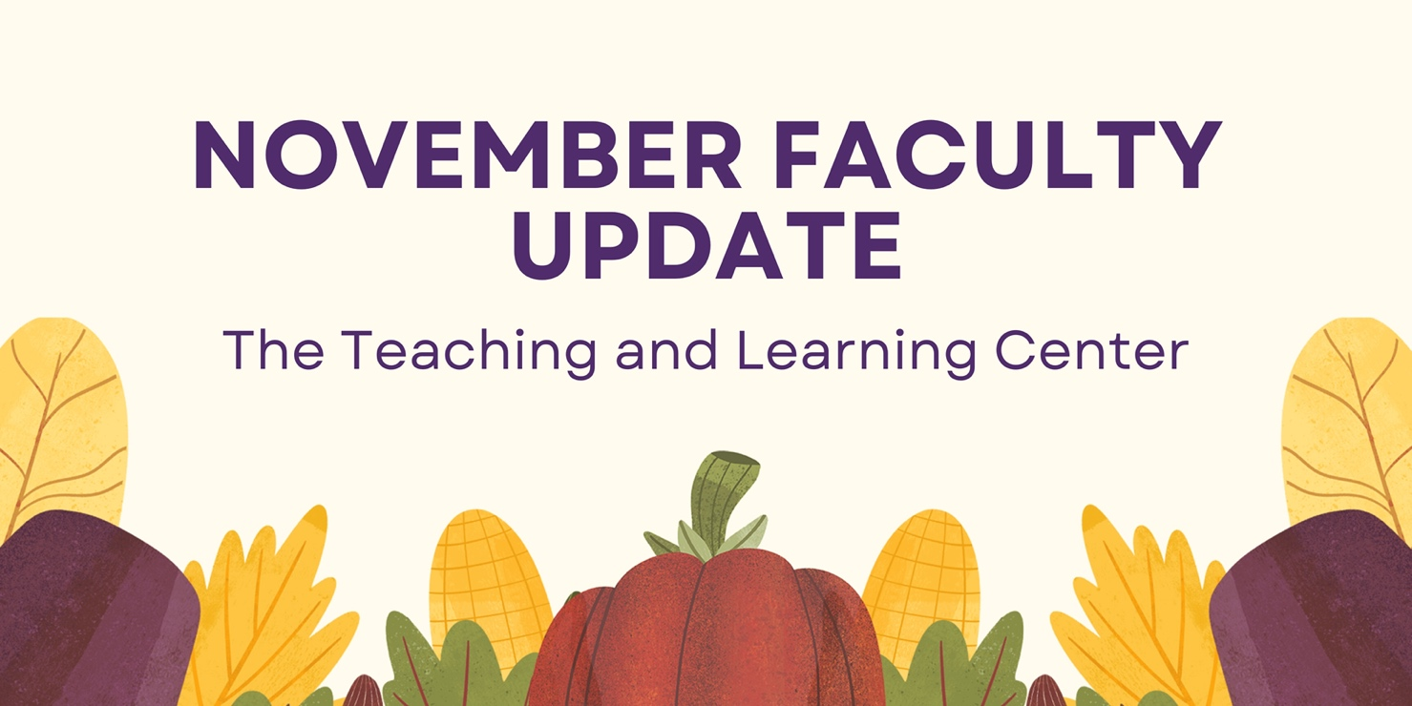

Open Initiatives

Teaching Circle: Grading Practices
Are you interested in exploring new grading approaches or moving to a new grading practice? Consider joining the Spring 2024 teaching circle on grading practices, which will include looking at ungrading techniques, specification grading, standards grading, and contract grading.

Participants will spend approximately 10 hours over the semester engaged with the program.

For more information, see the full program description on our website. If you're interested in participating, please complete the Teaching Circle registration form.

Teaching Squares: An Opportunity for Peer Observation and Self-Relfection
We are excited to invite you to join the new Teaching Squares program that will run in Spring 2024! The Teaching Squares program will create “squares” of four faculty members who agree to visit each other’s classes over the semester and meet to discuss what they have learned about their own teaching from the observations. The process is non-evaluative and is based on reciprocity, shared responsibility, and mutual respect. Partners will observe each other to gather ideas on different teaching approaches that might be used in their own classes.

Participants can expect to spend approximately 8 hours over the semester engaged with the program. All faculty are eligible to participate.

For more information, see the full program description on our website. If you’re interested in participating, please complete the Teaching Squares registration form by Friday, December 1.

Upcoming Events & Workshops

New! Teaching Strides
The last two Teaching Strides of the Fall are:
- 11/07 - Student Engagement Strategies
- 11/14 - Equitable Course Design
Join us for a walk around campus and a discussion on these topics (and more).

Teaching Strides will return in Spring 2024. To better accommodate busy schedules, we are asking those interested in participating to sign up, and then we will work to find a common time for our weekly walk. Be on the lookout for the registration in next month’s newsletter.

Registration Open: Teaching with AI Webinar Series
Build your AI literacy by attending a three-part webinar series on incorporating AI tools and strategies into your instructional practice. Hosted by TLC staff, these hour-long Zoom sessions start with a brief overview of generative AI, spend 30 minutes on the session’s topic, and end with time for questions and conversation. The first workshop will focus on Constructing Assessments and will be held on Monday, November 13 at 10:00am. Register for the last session today!

Faculty Fusion: Hot Topics with the TLC
Need help transitioning out of holiday mode before the Spring semester? Looking for ways to keep Winter class momentum rolling? Register today for Faculty Fusion!
- When: January 17, 2024 from 9:00am to 1:00pm
- Where: The Foundation
- What: An in-person set of three interactive panels covering hot topics to help you prepare for the new semester.

Featured "hot" topics:
- Pedagogy of Care: Supporting Mental Health through Instructional Practices
- Using AI for Teaching
- Addressing Micro-Aggressions in the Classroom

Each session will include 30 minutes of presentation from a panel of WCU faculty experts, followed by 20 minutes of Q&A and table conversations with your peers. Coffee and lunch will be provided.

Program Updates

Online Faculty Development Program
Faculty interested in completing OFD can now self-enroll into the program’s D2L site using the Discover feature and start working when it fits their schedule. More details are available in the New OFD Announcement. If you have any questions about these changes, please contact the Teaching and Learning Center.

If you are interested in serving as a peer reviewer for new OFD modules currently under development, please complete the peer reviewer interest form. Selected faculty would spend 2 to 3 hours reviewing content drafts of new modules, providing their feedback and perspective.

Stay Connected

ODLI on Air Podcast
Did you catch the episode with our first four-legged guest? Practices in Well-Being with Dr. Rachel Daltry & Muddy Puddles

On 11/8, our next episode is available - Building a Community Engagement Experience with Professor Gordon, Dr. Lightner, and Dr. Solic

Listen to all of our episodes, or leave us a comment or review on your favorite podcast platform.

Connect with Us
The Teaching and Learning Center is far more than just a newsletter! Our website hosts a variety of teaching resources and our full Event Calendar. To get in touch, feel free to send us an email, or stop by our drop-in hours to speak live with one of our designers.

