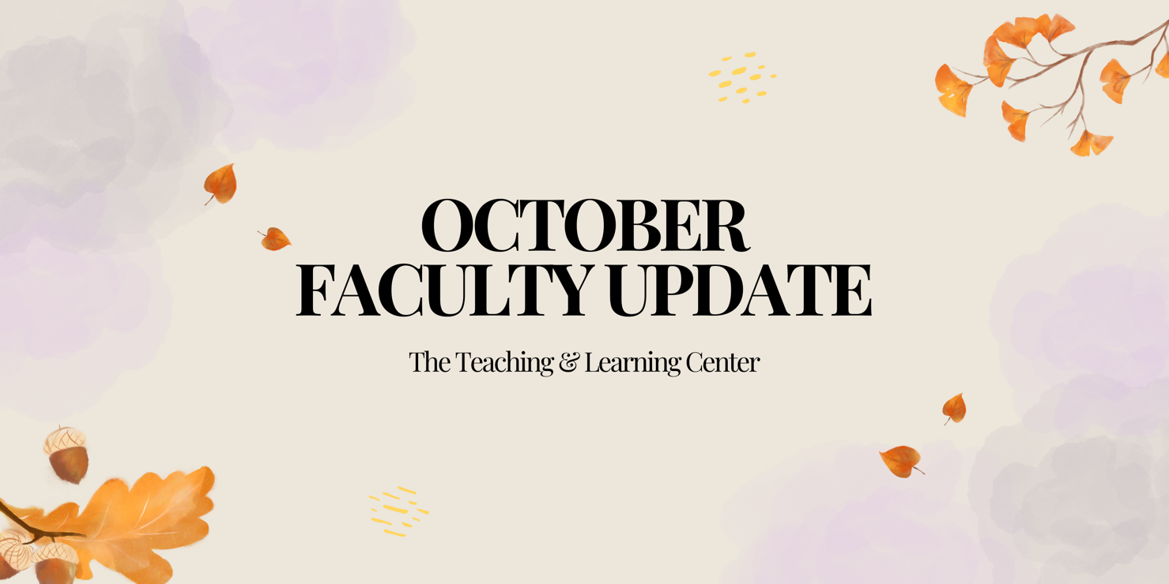

# Open Calls & Initiatives

## (Due Nov 3) Faculty Fusion 2025: Calling Interested Panelists & Moderators

[Faculty Fusion](https://wcu-tlc.org/pd/2025-faculty-fusion-hot-topics-with-the-tlc/) will return to the Foundation on January 15, 2025 with three new topics to kick off the spring semester:

1. Fostering Student Agency, Ownership, and Leadership
2. Innovative Teaching, Impactful Research: Transforming Classroom Policies into Scholarship
3. Matching Accommodations to Reality - Strategies to Help Faculty meet Student Needs

Are you interested in being a faculty panelist or moderator for one of our topics? Complete the [call for interest form](https://wcupa.co1.qualtrics.com/jfe/form/SV_0DK1sgxpkpdQ2IC) by **Sunday, November 3**, and a member of the TLC staff will reach out to learn more about your expertise and ideas.

## (Due Nov 24) Spring 2025 Student-Faculty Teaching Collaborations Program

Are you interested in getting student feedback and perspectives on your teaching practices? Do you want to boost your teaching confidence or reignite your passion for teaching? If so, consider participating in the [Student-Faculty Teaching Collaborations Program](https://www.wcupa.edu/tlc/student-faculty-collab.aspx) during the Spring 2025 semester! This program pairs you with two WCU students who will provide frequent and varied feedback on one of your courses from their perspective.

To learn more, [visit our website](https://www.wcupa.edu/tlc/student-faculty-collab.aspx), or to apply, review the [Student-Faculty Teaching Collaborations Call for Applications](https://wcupa.co1.qualtrics.com/jfe/form/SV_cLMrRwBREjOeV70). Applications are due **Sunday, November 24**.

## (Fall 2024) Faculty Advance Book Club

The Multicultural Faculty Commission is launching the Faculty Advance Book Club, sponsored by ODEI and TLC. If you're interested in discussing and advancing equity in higher education, join us in conversation and gain insights from others as we discuss [*Stories from the Front of the Room: How Higher Education Faculty of Color Overcome Challenges and Thrive in the Academy*](https://rowman.com/ISBN/9781475825183/Stories-from-the-Front-of-the-Room-How-Higher-Education-Faculty-of-Color-Overcome-Challenges-and-Thrive-in-the-Academy) by Michelle Harris, Sherrill L. Sellers, Orly Clerge, and Frederick W. Gooding.

For more information, please visit [our website](https://www.wcupa.edu/tlc/book-clubs.aspx), or if you have any questions, please contact Janet Chang ([jchang@wcupa.edu](mailto:jchang@wcupa.edu?subject=FMC%20Book%20Club)).

## (Fall 2024) *Unmasking Autism* Book Club

Are you interested in learning more about neurodiversity and building community on campus? Join the upcoming book club where students, faculty, and staff are invited to read and discuss [*Unmasking Autism*by Devon Price](https://bookshop.org/p/books/unmasking-autism-discovering-the-new-faces-of-neurodiversity-devon-price/17622818)*.*

For more information, [check out our blog](https://wcu-tlc.org/pd/upcoming-book-club-unmasking-autism-by-devon-price/), or if you're already interested in joining, [register today](https://docs.google.com/forms/d/e/1FAIpQLSfw-lgq97VwmLIrDxdHKVOuCFArgfSYLZx8oA3HsQt4sByq-g/viewform)! If you have any questions, please contact Jacqueline Alnes ([jalnes@wcupa.edu](mailto:jalnes@wcupa.edu)).

## (Due Nov 1) Psychological Safety of Higher Education Faculty Study

Kelly Fisher and Tom Pantazes, with support from Anita Foeman, are conducting an anonymous survey of WCU faculty psychological safety in the classroom; participants will also have the option to engage in a one-on-one or focus group interview. This study has been approved by the WCU Institutional Review Board, protocol IRB-FY2024-286, and the results will help inform our understanding of West Chester University’s campus psychological safety.

The researchers invite you to participate in this study by completing the [Psychological Safety of Higher Education Faculty survey](https://wcupa.co1.qualtrics.com/jfe/form/SV_en6ljaa9YhoQwDQ). The deadline to participate is **Friday, November 1**. Your participation is most appreciated.

Questions can be directed to Kelly Fisher ([kfisher@wcupa.edu](mailto:kfisher@wcupa.edu?subject=)) and Tom Pantazes ([tpantazes@wcupa.edu](mailto:tpantazes@wcupa.edu?subject=)).

# Upcoming Events

**(In-person: Oct 8) Teaching in Turbulent Times**

As a University that values diversity and inclusion, how can you ensure that our classrooms and other learning environments are places for civil discourse and respectful disagreement? This discussion will allow faculty and staff to explore this issue by examining case studies and proactively plan for these moments. This workshop was created by Dr. Tracey Robinson and is designed for participants to explore strategies for maintaining civil discourse and respectful disagreement in the classroom during contentious moments. Dr. Robinson will facilitate alongside Dr. Janneken Smucker.

[Register today](https://wcupa.co1.qualtrics.com/jfe/form/SV_3rfe6ALLU9gJHw2) for the in-person session on **Tuesday, October 8**!

## (Virtual: Oct 24) Strategies for Improving Class Attendance

Join us on Zoom on **Thursday, October 24**for an hour-long exploration of research-based strategies to cultivate student engagement, spark motivation, and promote regular class attendance and participation. [Register today!](https://wcupa.zoom.us/meeting/register/tJYpde6qqT0oHNYHCS5nR5JaSB7MT9SBe7Q8#/registration)

## (In-person: Nov 11) Join Us for the Fall 2024 Tech Talk!

**When:** Monday, November 11 from 12:00pm to 1:00pm

**Where:** Anderson Hall, Room 125

Light refreshments will be provided.

The goal of Tech Talk is to bring together faculty across different departments on campus to share their innovative uses of technology in teaching and learning, and to exchange ideas. During this Fall 2024 offering, Nursing Department Chair and Associate Professor, Dr. Nancy Barker, will share how she is using VTS Editor to create interactive learning activities that boost student engagement and comprehension.

If you're interested in attending, please RSVP via the [Fall 2024 Tech Talk Form](https://wcupa.co1.qualtrics.com/jfe/form/SV_804yGBdi4pJt3U2)at your earliest convenience. If you have any questions about this offering, please contact Jessica Drass at [jdrass@wcupa.edu](mailto:jdrass@wcupa.edu?subject=).

## (In-person: Jan 15) Faculty Fusion 2025: Save the Date!

Save the date for [Faculty Fusion](https://wcu-tlc.org/pd/2025-faculty-fusion-hot-topics-with-the-tlc/)!

* **When:** **January 15, 2025** from 9:00 am to 1:00 pm
* **Where:** The Foundation
* **What:** An in-person set of three interactive panels covering hot topics to help you prepare for the new semester.

Panel topics include:

1. Fostering Student Agency, Ownership, and Leadership
2. Innovative Teaching, Impactful Research: Transforming Classroom Policies into Scholarship
3. Matching Accommodations to Reality - Strategies to Help Faculty meet Student Needs

Each session has 30 minutes of presentation from a faculty panel followed by 20 minutes of Q&A and table conversations with your peers. Watch this space for registration details, or reach out to [tlc@wcupa.edu](mailto:tlc@wcupa.edu?subject=) with any questions.

# Program Updates

## Online Faculty Development Program

Need to earn or renew your CAPC distance education credential? Faculty can now self-enroll into the OFD program’s D2L site using the [Discover feature](https://wcupaprod.service-now.com/kb?id=kb_article_view&sysparm_article=KB0010869)! Start working whenever it fits your schedule.

# Stay Connected

## Discover the TLC Blog

Dive into a wealth of resources designed to enhance your teaching and learning experience! Our blog features the [latest event information](https://wcu-tlc.org/category/pd/), [insightful podcast episodes](https://wcu-tlc.org/category/podcast/), and engaging posts from [faculty](https://wcu-tlc.org/ai/ai-source-project-students-writing-about-ai/) and [staff](https://wcu-tlc.org/course-design/preparing-for-challenging-discussions-in-the-classroom-with-community-agreements/) on a variety of teaching topics. Whether you're looking for innovative strategies, inspiration, or community insights, the [TLC Blog](https://wcu-tlc.org/) is your one-stop shop for all things teaching.

## ODLI on Air Podcast

This month, learn more about the Faculty Mentoring Program in a conversation with Dr. Colwell and Dr. Ocasio publishing on October 9, or hear how Dr. McQueen utilizes numerous teaching strategies to effectively engage students in a diversity course.

As always, you can catch up on previous episodes in the [ODLI on Air catalog](https://open.spotify.com/show/7dlveEuHbzzJ9BfgotUyq8) anytime, or you can reach out to us at [tlc@wcupa.edu](mailto:tlc@wcupa.edu) to join the show.

## Connect with Us

The Teaching and Learning Center is far more than just a newsletter! Our website hosts a variety of [teaching resources](https://www.wcupa.edu/tlc/teaching-resources.aspx) and our full [Event Calendar](https://www.wcupa.edu/tlc/events.aspx). To get in touch, feel free to [send us an email](mailto:tlc@wcupa.edu?subject=), or stop by our [drop-in hours](https://www.wcupa.edu/tlc/drop-in.aspx) to speak live with one of our designers.