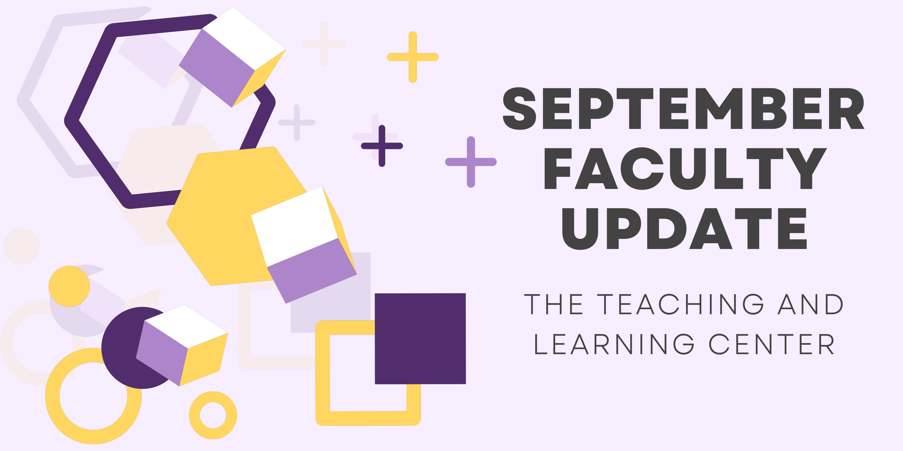

Open Initiatives

Call for Applications: Diversity & Inclusion Faculty Learning Community
Are you passionate about teaching but wonder who you might be leaving behind in class? Do you need help getting started with inclusive teaching? The Diversity and Inclusion Faculty Learning Community (DIFLC) might be for you! Together, we will build better skills in promoting equity and diversity in the classroom, discuss challenges we face when creating inclusive learning environments, and construct guidelines for equitable teaching.
The FLC will meet six times throughout the 2023-24 academic year via Zoom on Thursday evenings. All faculty are eligible to participate. Participating faculty will receive a stipend of $500 for the year, as well as several topical books.
If you’re interested in the DIFLC, apply by completing the brief DIFLC Survey by September 15, 2023. For more information, please review the DIFLC Call for Applications.
If you have any questions, please contact the DIFLC co-facilitators, Dr. Kimberly E. Johnson (kjohnson4@wcupa.edu) and Dr. Zeinab Baba (zbaba@wcupa.edu).

Call for Proposals: Quality Matters Initiative
With the rapid growth of online education at West Chester University, the Teaching and Learning Center looked to ensure that our online courses are built upon research-backed standards. Therefore, we partnered with Quality Matters (QM), a non-profit organization that specializes in standards for quality assurance for online course and program design. We run this initiative each academic year in which faculty members are compensated for preparing their courses for review and obtaining QM certification. More details about the opportunity are available on the Call for Proposals.
Applications are due by Friday, October 6, 2023.

Opening Soon: eTextbook Initiative
Through our eTextbook Initiative, faculty help combat the rising costs of textbooks by learning how to build their own high-quality, interactive electronic textbooks. These completed eTextbooks are then provided to WCU students for free, helping to lower the overall cost of their education while removing the financial barrier to obtaining these educational materials. As of the Spring 2023 semester, books produced by the initiative have eliminated over $150,000 in student costs.Please look out for an email in the coming weeks with a Call for Participation and more information, and if you are interested in participating, contact Marc Drumm at mdrumm@wcupa.edu.

Upcoming Events & Workshops

New! Teaching Strides
Join us this Fall for a new professional development opportunity that combines physical activity with meaningful conversation! Each Tuesday, meet at the Ram Statue in front of Old Library at 11:30 am to join us for a discussion on a teaching related topic or theme as we walk around campus. To learn more, visit our website.
Not interested in walking, but still want to talk about the week’s teaching topic? Join us on Wednesday at 11:30 on Zoom for 30 minutes of conversation around each week’s topic.
- 09/12 - Student Engagement Strategies
- 09/19 - Effective Assessment Methods
- 09/26 - Balancing Teaching and Research
- 10/03 - What to Do about AI?

Active Listening and Enacting Empathy
Join TLC's Faculty Mentoring Committee for a presentation on Active Listening and Enacting Empathy by Dr. Stephen M. DiDomenico, Assistant Professor of Communication Studies, on Monday, September 18 from 12:00 - 12:50pm or Tuesday, September 19 from 12:30 - 1:20pm. All faculty are welcome to attend. Registration is not required: to attend the presentation, simply join us on Zoom!
Questions about the event can be directed to Michelle Blake (mblake@wcupa.edu) or Ralph Sorrentino (rsorrentino@wcupa.edu).

Registration Open: CELT Book Club
Join the CELT Book Club this fall semester to read and discuss Relationship-Rich Education: How Human Connections Drive Student Success in College by Peter Felten and Leo M. Lambert (2020). Because the West Chester University Library has an unlimited e-book license for this title, CELT will offer our book club selection as an e-book rather than send hard copies. You may access the book here, when logged in to the library with your WCU credentials.
We will have two meetings during the semester:
- Wednesday, Oct. 4 at 3:00 PM or Thursday, Oct. 5 at 12:30 PM
- Wednesday, Nov. 8 at 3:00 PM or Thursday, Nov. 9 at 12:30 PM
Register now and download the book to start reading!

Registration Open: Teaching with AI Webinar Series
Build your AI literacy by attending a three-part webinar series on incorporating AI tools and strategies into your instructional practice. Hosted by TLC staff, these hour-long Zoom sessions start with a brief overview of generative AI, spend 30 minutes on the session’s topic, and end with time for questions and conversation. The first workshop will focus on Conversations with Studentsand will be held on Wednesday, September 13 at 10:00am. Register for 1, 2, or all 3 webinars!

Registration Open: Navigating Classroom Discussions Across Difference
Are you eager to create an inclusive and dynamic learning environment? If so, this workshop is for you! Led by faculty member, Shannon McQueen, and student leader, Corey Lane, this interactive session will delve into the art of cultivating engaging discussions across differences in the classroom. Join us as we collectively strive to make our classrooms more vibrant, equitable, and enriching places of learning!

This workshop will be held on Wednesday, October 11 at 12:00pm in Anderson Hall, conference room 306. For more information, see the Navigating Classroom Discussions Flyer, or register now!

Program Updates

Call for Peer Reviewers: New Online Faculty Development Program Modules
Faculty interested in completing OFD can now self-enroll into the program’s D2L site using the Discover feature and start working when it fits their schedule. More details are available in the New OFD Announcement. If you have any questions about these changes, please contact the Teaching and Learning Center.

If you are interested in serving as a peer reviewer for new OFD modules currently under development, please complete the peer reviewer interest form. Selected faculty would review content drafts of new modules, providing their feedback and perspective. Modules under development include:
- Assessing and Providing Feedback
- Beyond Blooms: A Deep Dive on Objectives
- Equitable Teaching
- Connecting with Students
- Creating and Assessing Online Discussions
- Select Response Assessment Design
- Basics of Instructional Video Creation
- Game Based Learning & Gamification
- Hyflex

Stay Connected

Welcome to our Instructional Design Assistants!
This semester, three graduate students are joining TLC to provide support for projects. We'd like to welcome:
Nicholas Gavin
Nicholas Gavin is a current MBA Candidate at West Chester University. After graduating from WCU in Spring 2023 with his B.S. in Business Management, Nick is thrilled to gain experience within a higher education setting and explore the wide range of responsibilities managed by the Teaching and Learning Center. In his free time, Nick enjoys trying new restaurants and bakeries, paddle boarding, and spending time with friends and family.
Jisha S Kumar
Jisha S Kumar is pursuing a graduate program in Computer Science at West Chester University. Originally from India, she has a background in Engineering. Throughout her academic journey, she has been fortunate to engage in software development, which ignited her passion for doing higher studies. Jisha is excited to be a part of the University and contribute to our shared goals.
Supraja Rama Meka
Supraja Rama Meka is a Computer Science Master's Candidate at West Chester University from India. As a tech enthusiast, she enjoys UI designing and developing, and her enthusiasm to learn and explore the world of technology has ignited her passion for higher studies in the USA. In her free time, she enjoys dancing and reading comics.

ODLI on Air Podcast
Season 3 is here! New episodes to check out include:
- Supporting Student Athlete Mental Health with Dr. Lindsey Keenan and the PROmotion App
- Amazing Academic Advising with Dr. Francis Atuahene releases 9/13
- Bringing Empathy to Nursing Education using 360 Video with Dr. Nancy Barker & Dr. Danielle Yocom releases 9/27
If you are interested in being a guest on the show, email us at tlc@wcupa.edu.
Want to record your own podcast? The audio recording studio is available for reservations.

Connect with Us
The Teaching and Learning Center is far more than just a newsletter! Our website hosts a variety of teaching resources and our full Event Calendar. To get in touch, feel free to send us an email, or stop by our drop-in hours to speak live with one of our designers.

